2020-21 SUS Admissions Tour MATRIX
Universities |  | 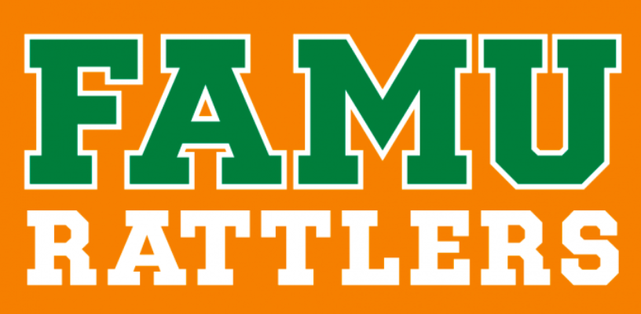 | 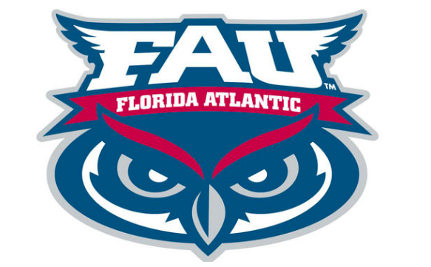 | 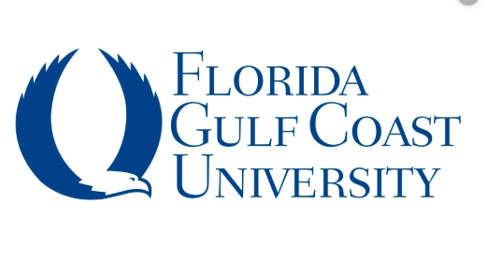 | 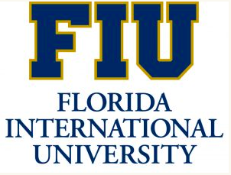 |  | 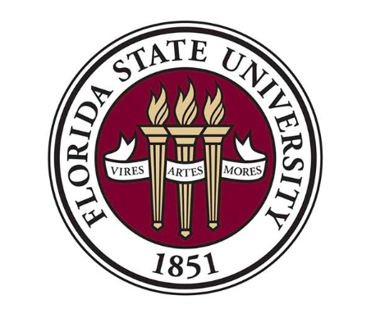 |  | 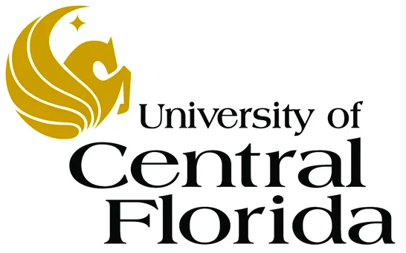 | 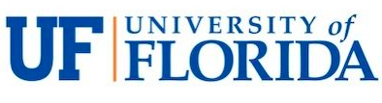 | 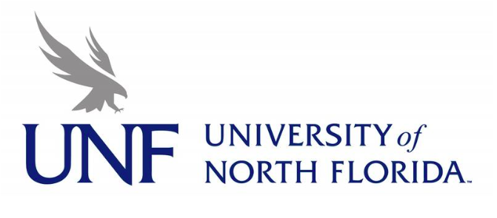 | 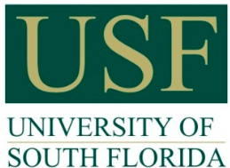
Location |  | Tallahassee | Boca Raton | Ft. Myers | Miami | Lakeland | Tallahassee | Sarasota | Orlando | Gainesville | Jacksonville | Tampa | Pensacola
Type of Applications Accepted |  | Institutional Only | Institutional or Common App | Institutional or Common App | Institutional Only | Institutional or Common App | Institutional, Common App, or Coalition App | Institutional or Common App | Institutional or Common App | Common App, Coalition App | Institutional or Common App | Institutional, Common App or Coalition App | Institutional or Common App
Middle 50% of Admitted FTIC 2019  (S=Summer) (F=Fall) | GPA | S: 3.27  F: 3.67 | S: 3.18 - 3.76  F: 3.62 - 4.24 | S: 3.4 – 4.07  F: 3.51 – 4.26 | S: 3.6 - 4.2  F: 4.0 - 4.6 | F: 3.9- 4.6 | S: 3.8 - 4.3  F: 4.1 - 4.5 | F: 3.73 - 4.33 | S: 3.77 - 4.29  F: 3.96 - 4.46 | S: 4.4 - 4.6  F: 4.4 - 4.6 | S: 3.3 - 3.8  F: 4.0 - 4.5 | S: 3.7 – 4.0  F: 4.1 - 4.4 | S: 3.75  F: 3.9
 | SAT | S: 1060  F: 1100 | S: 1030 - 1160  F: 1110 - 1260 | S: 1020 -1180  F: 1080 - 1230 | S: 1100 - 1190  F: 1240 - 1360 | F: 1280 - 1400 | S: 1190 - 1300  F: 1290 - 1410 | F: 1150 - 1340 | S: 1170 - 1280  F: 1250 - 1370 | S: 1260 - 1400  F: 1340 - 1480 | S: 1070 - 1190  F: 1200 - 1320 | S: 1160 - 1190  F: 1270 - 1340 | S: 1140  F: 1173
 | ACT | S: 20.2  F: 22.3 | S: 20 - 25  F: 23 - 29 | S: 20- 23  F: 22 - 26 | S: 22 - 25  F: 26 - 31 | F: 28 - 32 | S: 26 - 30  F: 29 - 32 | F: 24 - 30 | S: 23 - 28  F: 26 - 30 | S: 28 - 32  F: 30 - 33 | S: 21 - 24  F: 25 - 28 | S: 24 - 25  F: 28- 30 | S: 23  F: 25
Application Waivers Accepted |  | SAT/ACT Fee Waiver, NACAC Fee Waiver | SAT/ACT Fee Waiver, NACAC Fee Waiver, Email from School Counselor, Written Request from Student, Documentation Demonstrating Participation in Free/Reduced Lunch | SAT/ACT Fee Waiver, NACAC Fee Waiver | SAT/ACT Fee Waiver, NACAC Fee Waiver, Email from School Counselor, Written Request from Student, Documentation Demonstrating Participation in Free/Reduced Lunch | SAT/ACT Fee Waiver, NACAC Fee Waiver, Email from School Counselor, Documentation Demonstrating Participation in Free/Reduced Lunch | SAT/ACT Fee Waiver, NACAC Fee Waiver Participation in Free/Reduced Lunch | SAT/ACT Fee Waiver, NACAC Fee Waiver, Email from School Counselor, Written Request from Student, Documentation Demonstrating Participation in Free/Reduced Lunch | SAT/ACT Fee Waiver, NACAC Fee Waiver, Demonstrating Participation in Free/Reduced Lunch | SAT/ACT Fee Waiver, NACAC Fee Waiver, Email from School Counselor, Written Request from Student, Documentation Demonstrating Participation in Free/Reduced Lunch | SAT/ACT Fee Waiver, NACAC Fee Waiver, Email from School Counselor, Documentation Demonstrating Participation in Free/Reduced Lunch | SAT/ACT Fee Waiver, NACAC Fee Waiver, Email from School Counselor, Written Request from Student, Documentation Demonstrating Participation in Free/Reduced Lunch | SAT/ACT Fee Waiver, NACAC Fee Waiver, Email from School Counselor, Written Request from Student, Documentation Demonstrating Participation in Free/Reduced Lunch
Self-reported Student Academic Record (SSAR) |  | Yes | Yes | Yes | No  Send official transcript | Yes | Yes | Yes | No  Uses SPARK | Yes | Yes | No  Send official transcript | No
Super Score SAT |  | Yes | Yes | Yes | Yes | Yes | Yes | Yes | Yes | Yes | Yes | Yes | Yes
Super Score ACT |  | Yes | Yes | Yes | Yes | Yes | Yes | Yes | No | Yes | Yes | Yes | Yes
Transfer:  2+2 Enhancement Programs |  | Ignite Program | Link | Destination FGCU | Connect- 4Success | Polk State College & South Florida State College (EE) | TCC2FSU | Guaranteed Admission Program | DirectConnect to USF | Gator Engineering; Gator Design and Construction | SF2UNF;  FSCJ/UNF Connect; UNF/SJR State Gateway | FUSE | 2UWF

2020-21 SUS Admissions Tour MATRIX
Universities
Fall 2021 Deadlines | Deadlines | 1st: 11/1/20  2nd: 3/1/21 | 1st: 2/15/21  2nd: 4/15/21 | 1st: 11/1/20  2nd: 3/1/21 | 4/1/21 | 1st: 11/1/20  2nd: 4/1/21 | 1st: 12/1/20  2nd: 3/1/21 | 1st: 12/1/20  2nd: 7/1/21 | 5/1/21 | 1st: 11/1/20  2nd: 3/1/21 | 7/1/21 | 11/1/20 | 1st: 12/1/20
 | Notification Dates | 1/15/21 | Rolling | Febrary | Rolling |  | 1st: 2/18/21  2nd: Rolling | Weekly beginning 10/15/20 | Rolling | 1st: 2/26/21  2nd: 3/26/21 | Rolling | 11/15/20 | Rolling
 | Priority Date for Aid & Scholarships | 11/1/20 | 12/1/20 | 11/1/20 | 11/15/21 | 11/1/20 | 12/1/20 | 11/1/20 | 12/1/20 |  | 10/15/20 | 1/15/21 | 1/1/21

State University System of Florida: https://www.flbog.edu/universities/

